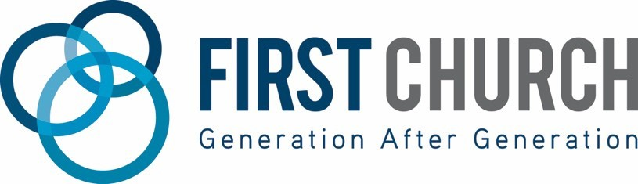
Internship & Residency Framework

Helping Generation after Generation become fully devoted followers of Christ,
by training and equipping the next generation of church leaders.

Specific Internships & Residency offered:
- Worship Arts & Production
- Family Ministries
- Next Step’s / Communications

Degrees of Focus (or related):
- Undergraduate
  - Organizational Leadership / Communications
  - Biblical Studies / Ministry degrees
  - Youth & Children’s Ministry
  - Worship Arts / AV Production
- Masters
  - M. Divinity

Type:
- Full time & Part time internships available depending on education requirements.

Internship Timeframes:
- Summer – May/June/July/August
- Fall – Sept/Oct/Nov/December
- Spring – Jan/Feb/March/April

Residency Timeframe:
- 1 or 2 years

Costs:
- Internships
  - While internships are free & unpaid, the church does provide housing and food accommodations with a host family within the church. The cost to cover your expenses with the host family are:
    - 3–6-month internship (cost: $1-2,000)
- Residency
  - Residency is for students who are preparing to launch into full time ministry and are interested to continue their learning in a 1-2 year full-time intensive to gain mastery level skills and knowledge in their respective area.
    - Pay is negotiated with minimum 1-year commitment.
    - Host families available upon request

Transportation:
- The Intern or Resident is responsible to provide their own transportation throughout the learning experience.

What does First Church provide:
- Access and coaching from key ministry leaders.
- Weekly meetings & mentorship
- Training and opportunity to execute your education & training in real ministry contexts and make a real eternal impact to advance the gospel in the church.
- Housing & meals with a host family in the church
- Collaboration with your college / university to meet your Internship / Practicum requirements for your degree.
- *Exceptional Candidates ONLY - Consideration for long term employment in one of our campus’ post-graduation or post-residency.

What does the Intern provide:
- A lifestyle and heart consistent with Biblical values and in line with the churches statement of faith and core values
- A growth mindset and a “can do” attitude.
- Willingness to submit to our leadership, and the humility to receive coaching on how you can be better!

Next STEPS!

If you are ready to take your next step into Full Time Vocational Ministry, consider joining our team by reaching out to us at jobs@first.church with any questions that you have, or apply by:

Emailing us:
- Cover letter
- Your resume
- Your “God Story”
Join me in reading Next Steps: Learning to Tell Your God Story:
https://www.bible.com/en/reading-plans/39699

We can’t wait to hear from you!

